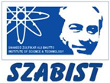 **Introduction to DevOps**

**BCS/BS 6A**

Lab: 04

# GROUP MEMBERS:

MUHAMMAD SHAYAN SHAHID (2212325)

MUHAMMAD ASHAD BAIG (2212115)

Task 1: Create a Web App

In this task, you will create an Azure App Service Web App.

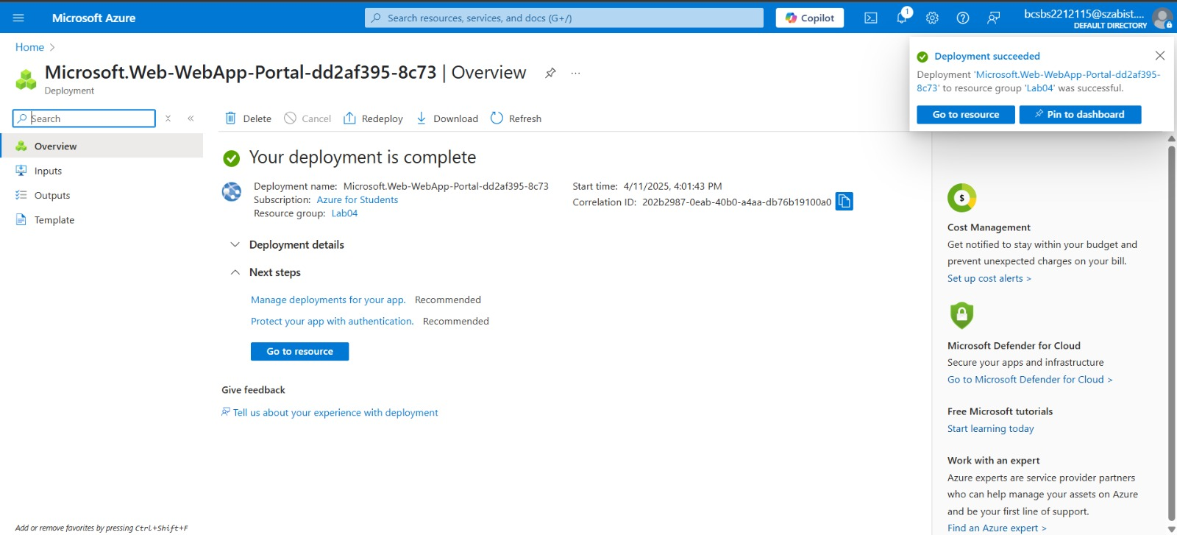

Task 2: Test the Web App

In this task, we will test the web app.

